Practical 1: LAN Design with Subnetting and Router ConfigurationAim:

Design a Local Area Network (LAN) using 3 PCs connected to a router.

Instructions:

• Assign each PC a unique subnet.

• Configure IP addresses and subnet masks.

• Configure the router interfaces to connect the subnets.

• Ensure all devices can communicate via the router.

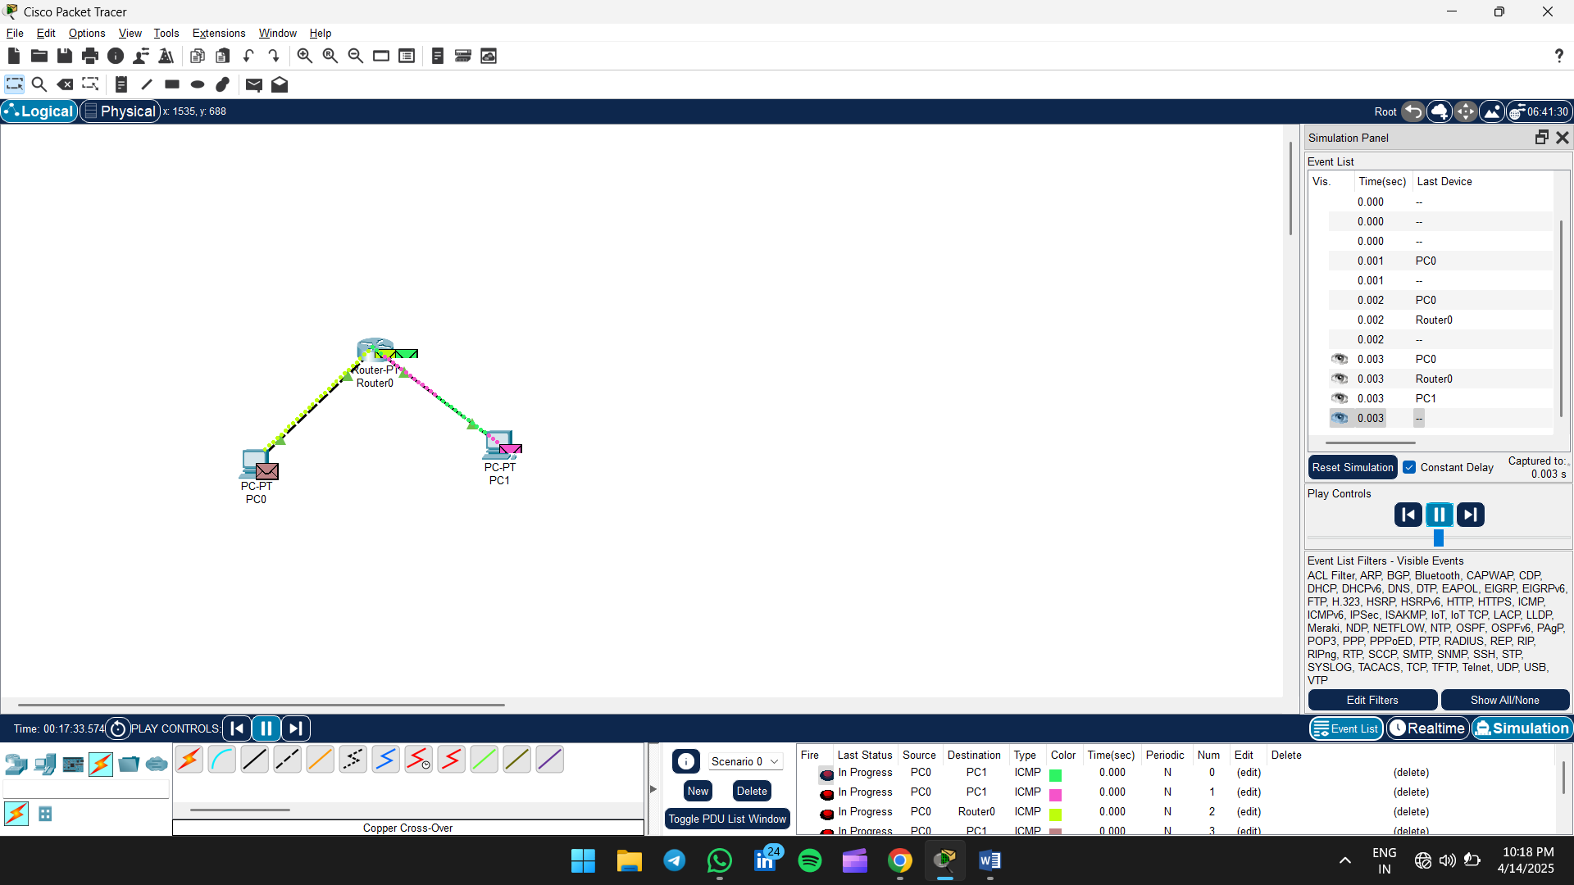

**1. Add Devices**

* **Drag and drop** the following from the bottom device list:
  + 1 Router (Router0)
  + 2 PCs (PC0 and PC1)

**2. Connect Devices**

* Use **Copper Cross-Over Cable**:
  + Connect **PC0 → Router0**
  + Connect **PC1 → Router0**

You can use **FastEthernet0 on PCs** and **GigabitEthernet0/0 or 0/1 on the router** depending on availability.

**3. Configure IP Addresses**

* **PC0 Configuration:**
  + Go to **Desktop > IP Configuration**
  + IP Address: 192.168.1.1
  + Subnet Mask: 255.255.255.0
  + Default Gateway: 192.168.1.254
* **PC1 Configuration:**
  + IP Address: 192.168.2.1
  + Subnet Mask: 255.255.255.0
  + Default Gateway: 192.168.2.254

**4. Configure Router Interfaces**

* Click on **Router0 > CLI** or **Config tab**, then configure interfaces:

enable

configure terminal

interface gigabitEthernet0/0

ip address 192.168.1.254 255.255.255.0

no shutdown

exit

interface gigabitEthernet0/1

ip address 192.168.2.254 255.255.255.0

no shutdown

exit

**5. Verify Connection**

* Use **Simulation Mode** to test ICMP (ping):
  + From **PC0 Desktop > Command Prompt**, type:
  + ping 192.168.2.1

You should see the ping packets go from PC0 → Router → PC1 and a successful reply if configured correctly.

Practical 2: Router-to-Switch Connection and Basic Configuration

Aim:

Connect a router to a switch and perform initial router configurations.

Instructions:

• Connect the router to the switch using proper cabling.

• Assign IP addresses to connected devices.

• Configure basic settings such as hostname, interface IP, and default gateway.

• Verify end-to-end connectivity using ping.

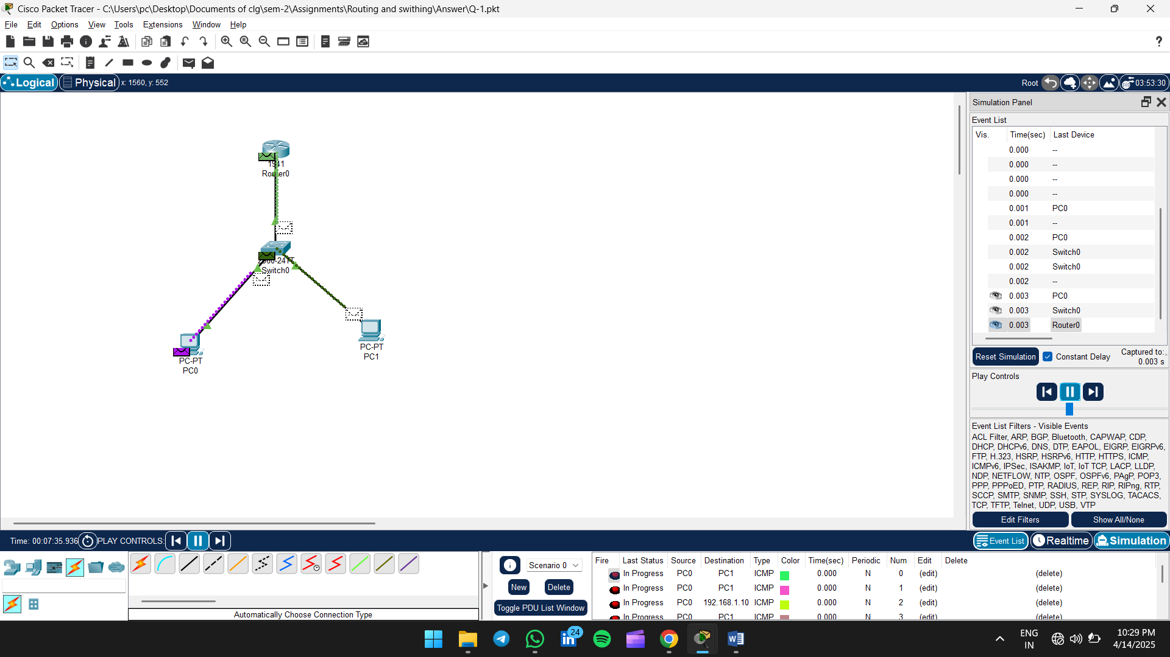

**1. Add Devices**

* 1 **Router** (e.g. Router0)
* 1 **Switch** (e.g. Switch0)
* 2 **PCs** (e.g. PC0, PC1)

**2. Connect Devices**

* Use **Copper Straight-Through Cable**:
  + Router0 ↔ Switch0 (e.g., Gig0/0 to FastEthernet0/1)
  + PC0 ↔ Switch0 (e.g., FastEthernet0/2)
  + PC1 ↔ Switch0 (e.g., FastEthernet0/3)

**3. Configure VLANs on the Switch**

1. Go to the **Switch CLI**:

enable

configure terminal

vlan 10

name VLAN10

vlan 20

name VLAN20

exit

1. Assign switch ports to VLANs:

interface fastEthernet0/2

switchport mode access

switchport access vlan 10

exit

interface fastEthernet0/3

switchport mode access

switchport access vlan 20

exit

1. Configure the trunk port (connection to router):

interface fastEthernet0/1

switchport mode trunk

exit

**4. Configure Router Subinterfaces for Inter-VLAN Routing**

Go to the **Router CLI**:

enable

configure terminal

interface gigabitEthernet0/0.10

encapsulation dot1Q 10

ip address 192.168.10.1 255.255.255.0

exit

interface gigabitEthernet0/0.20

encapsulation dot1Q 20

ip address 192.168.20.1 255.255.255.0

exit

interface gigabitEthernet0/0

no shutdown

exit

**5. Configure IP on PCs**

**PC0:**

* IP Address: 192.168.10.2
* Subnet Mask: 255.255.255.0
* Default Gateway: 192.168.10.1

**PC1:**

* IP Address: 192.168.20.2
* Subnet Mask: 255.255.255.0
* Default Gateway: 192.168.20.1

**6. Test Connectivity**

* Go to PC0 > Command Prompt:

ping 192.168.20.2

You should receive successful replies — meaning inter-VLAN routing is working properly.

Would you like to add **DHCP**, **DNS**, or **more VLANs** to this setup?

Practical 3: Setup a Small Office/Home Office (SOHO) Network

Aim:

Design and configure a basic SOHO network with internet access.

Instructions:

• Use a router, switch, and multiple PCs.

• Assign appropriate IP addresses.

• Configure DHCP (if required).

• Simulate internet connectivity using a cloud device.

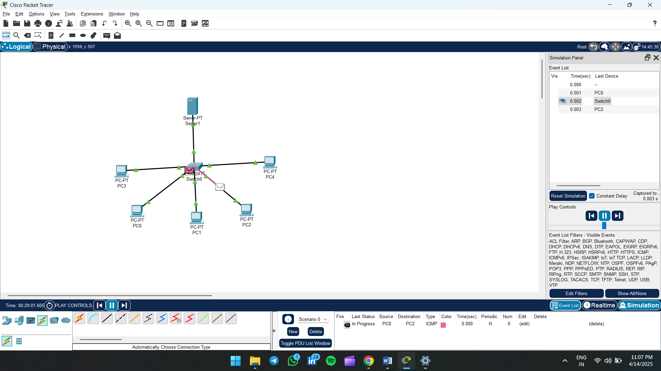

**1. Add Devices**

From the device selection at the bottom of Cisco Packet Tracer:

* 1 **Switch** (e.g., Switch0)
* 5 **PCs** (e.g., PC0 to PC4)
* 1 **Server** (e.g., Server0)

**2. Connect Devices to the Switch**

Use **Copper Straight-Through Cable** to connect each device to the switch:

* PC0 to Switch0
* PC1 to Switch0
* PC2 to Switch0
* PC3 to Switch0
* PC4 to Switch0
* Server0 to Switch0

(Connect all to different **FastEthernet ports**, like Fa0/1 to Fa0/6)

**3. Assign IP Addresses**

Use **manual IP configuration**:

| **Device** | **IP Address** | **Subnet Mask** | **Default Gateway (optional)** |
| --- | --- | --- | --- |
| PC0 | 192.168.1.1 | 255.255.255.0 | 192.168.1.254 (if needed) |
| PC1 | 192.168.1.2 | 255.255.255.0 | 192.168.1.254 |
| PC2 | 192.168.1.3 | 255.255.255.0 | 192.168.1.254 |
| PC3 | 192.168.1.4 | 255.255.255.0 | 192.168.1.254 |
| PC4 | 192.168.1.5 | 255.255.255.0 | 192.168.1.254 |
| Server0 | 192.168.1.10 | 255.255.255.0 | 192.168.1.254 |

To assign IPs:

* Click each **PC or Server**
* Go to **Desktop > IP Configuration**
* Manually enter the IP Address and Subnet Mask

**4. Test Connectivity**

To verify the LAN is working:

* Open **Command Prompt** on PC0
* Type:
* ping 192.168.1.3
* ping 192.168.1.10

If responses return without packet loss, your LAN setup is working correctly.

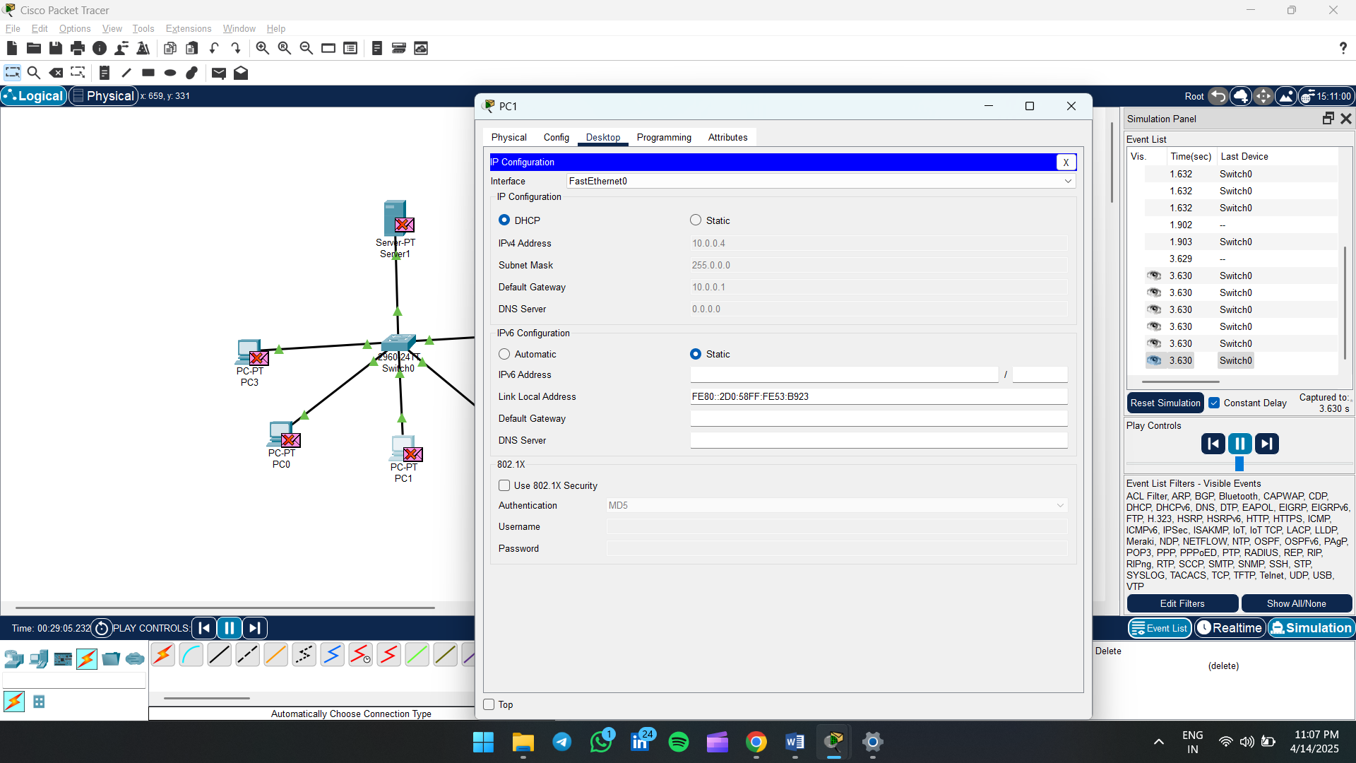

1. **Click on the PC** (e.g., PC1).
2. Go to the **Desktop** tab.
3. Click on **IP Configuration**.
4. Select **Static**.
5. Enter:
   * **IP Address**: 10.0.0.X (e.g., 10.0.0.4)
   * **Subnet Mask**: auto-fills as 255.0.0.0
   * **Default Gateway**: 10.0.0.1
6. Close the window.

Practical 4: Secure a Cisco Router or Switch with Passwords

Aim:

Secure access to Cisco devices using different types of passwords.

Instructions:

• Set a console password for accessing the device locally.

• Set an enable password for privileged mode.

• Configure VTY (telnet/SSH) passwords for remote access.

• Save the configuration and test login access

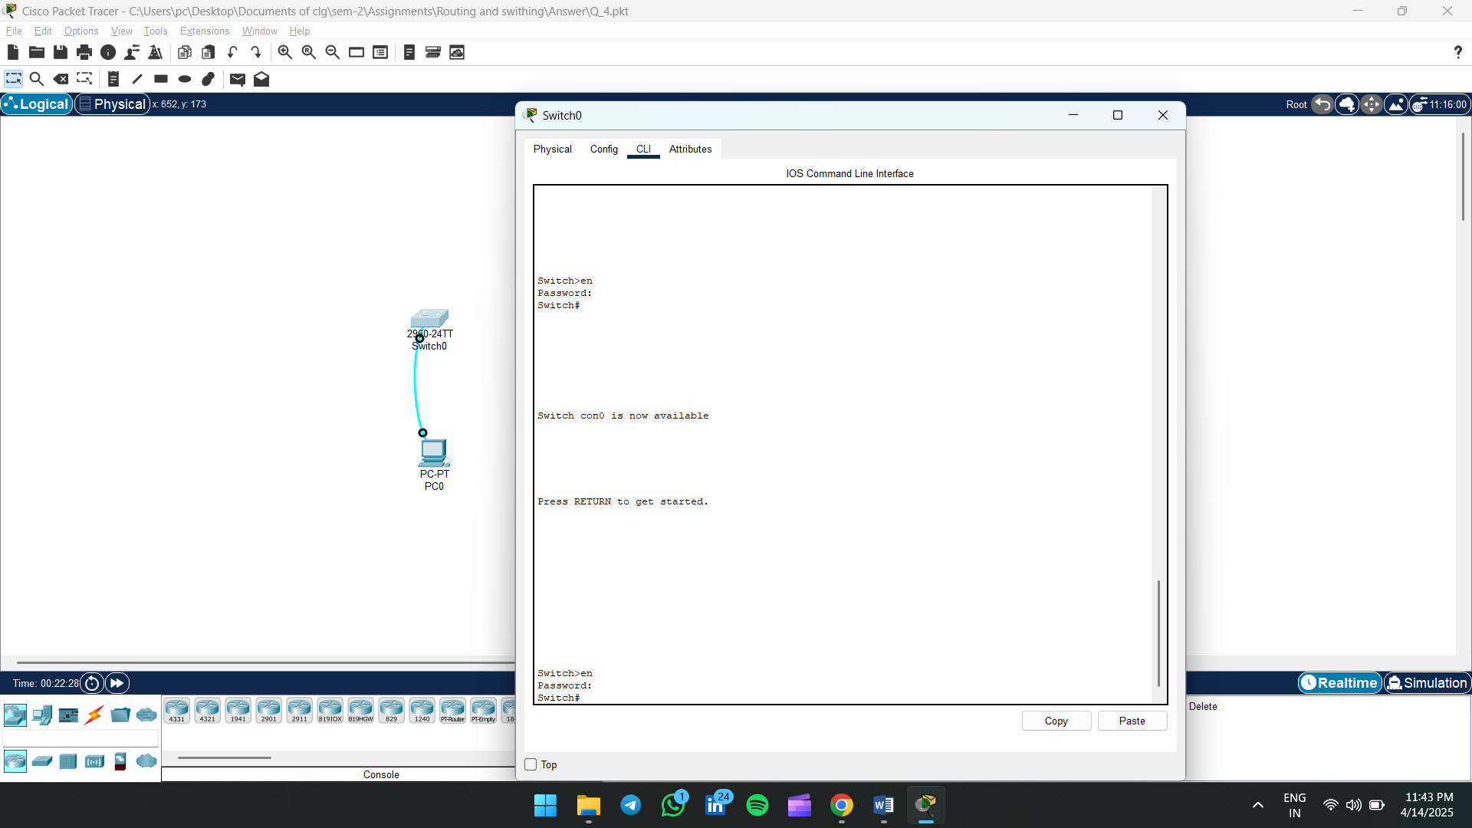

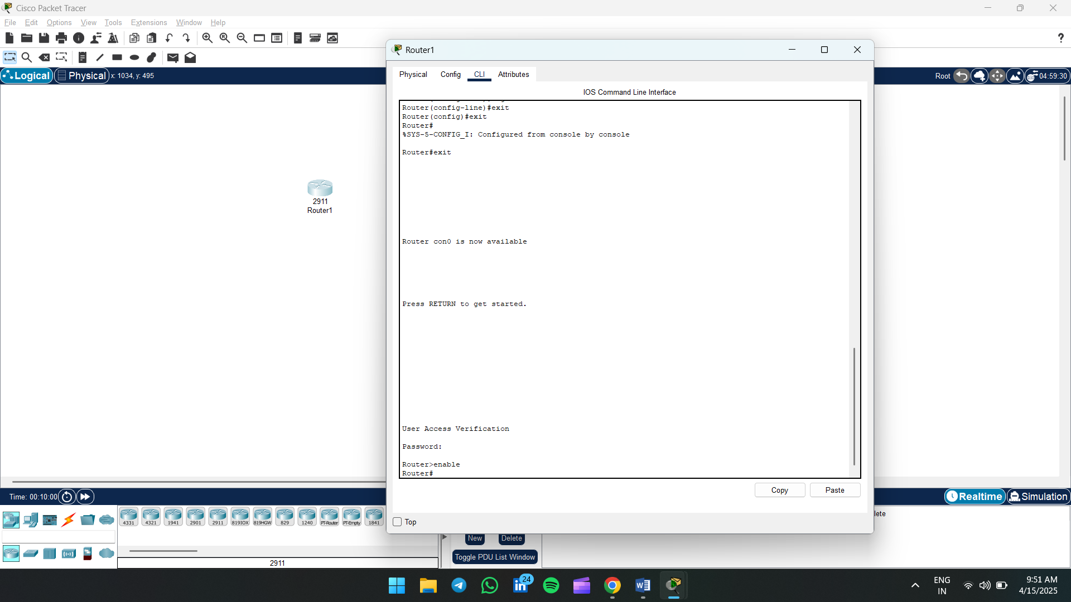

#### 1. ****Start the CLI****

When prompted, press Enter.

#### 2. ****Enter Privileged EXEC Mode:****

enable

#### 3. ****Enter Global Configuration Mode:****

configure terminal

#### 4. ****Set a Hostname (Optional):****

hostname Switch0

#### 5. ****Set Console Password:****

line console 0

password cisco

login

exit

#### 6. ****Set Enable Password:****

enable password class

#### 7. ****Set IP Address for VLAN 1 (Switch Management):****

interface vlan 1

ip address 192.168.1.2 255.255.255.0

no shutdown

exit

#### 8. ****Set Default Gateway (for remote access):****

ip default-gateway 192.168.1.1

#### 9. ****Save the Configuration:****

exit

write memory

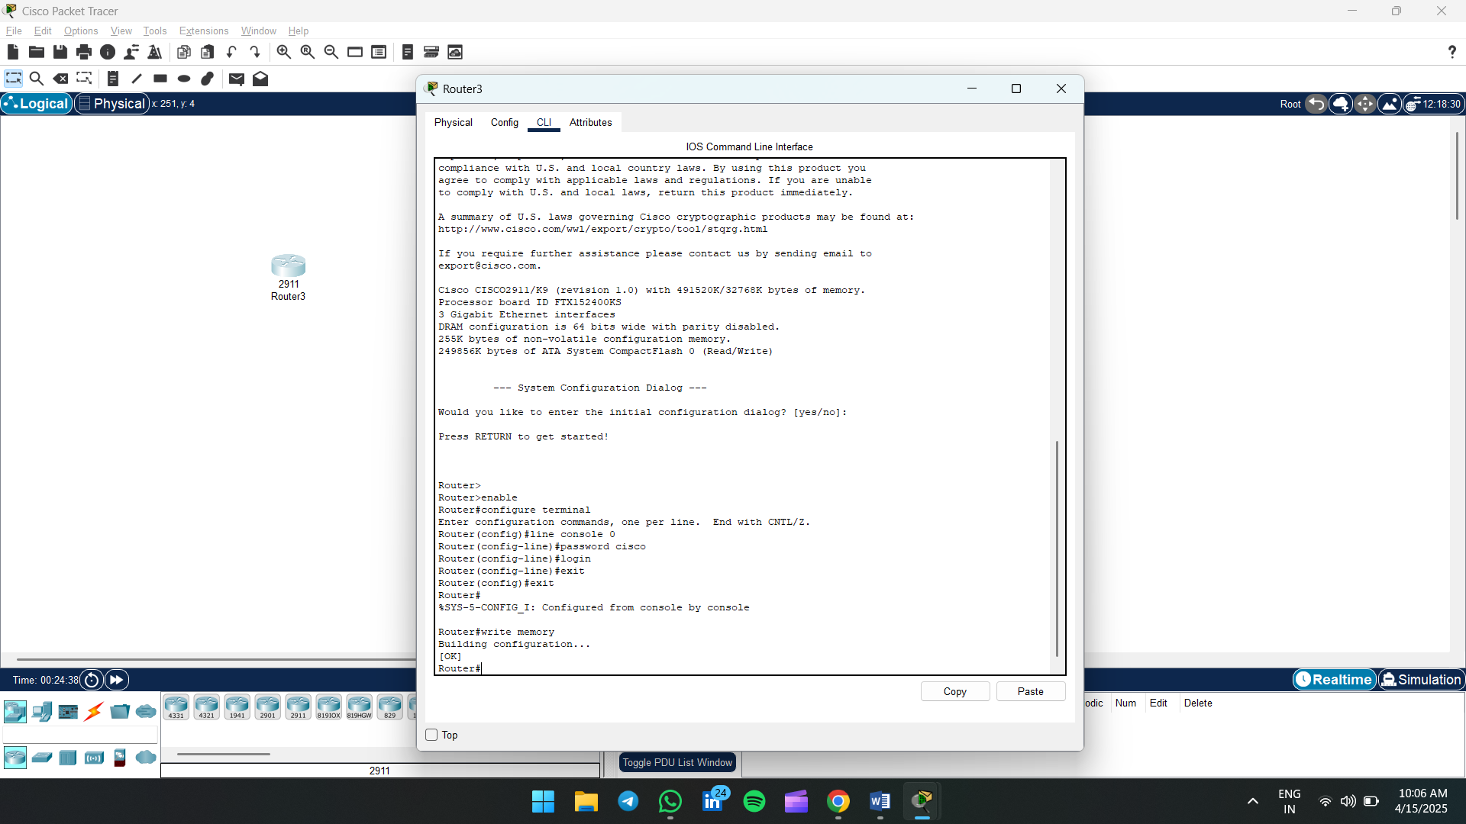

**1. Enter Privileged EXEC Mode:**

enable

**2. Enter Global Configuration Mode:**

configure terminal

**3. Set Console Password:**

line console 0

password cisco

login

exit

**4. Set Enable Password:**

enable password class

**5. Save the Configuration:**

write memory

✅ Now your router is secured with:

* Console access requiring the password cisco
* Privileged mode access requiring the password class

Practical 5: Configure RIP v2 on Multiple Router

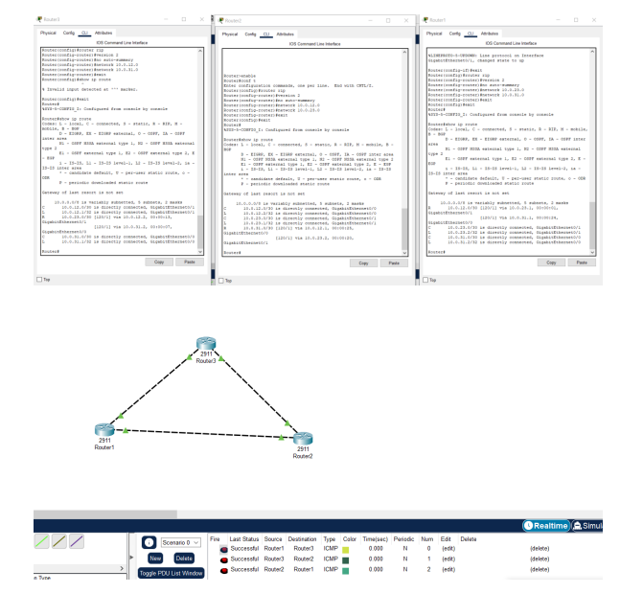

## 🔁 Static Routing Between 3 Routers

### 🛠 Step 1: Assign IP Addresses to Router Interfaces

Do this for **each router**:

enable

configure terminal

interface <INTERFACE_NAME>

ip address <IP_ADDRESS> <SUBNET_MASK>

no shutdown

exit

➡️ Example from your image:

**Router1:**

interface g0/0

ip address 12.0.0.1 255.255.255.0

no shutdown

exit

interface g0/1

ip address 13.0.0.1 255.255.255.0

no shutdown

**Router2:**

interface g0/0

ip address 12.0.0.2 255.255.255.0

no shutdown

exit

interface g0/1

ip address 23.0.0.2 255.255.255.0

no shutdown

**Router3:**

interface g0/0

ip address 13.0.0.3 255.255.255.0

no shutdown

exit

interface g0/1

ip address 23.0.0.3 255.255.255.0

no shutdown

### 🚏 Step 2: Configure Static Routes

On each router, add static routes to the **networks not directly connected**.

#### Router1:

ip route 23.0.0.0 255.255.255.0 12.0.0.2

#### Router2:

ip route 13.0.0.0 255.255.255.0 12.0.0.1

#### Router3:

ip route 12.0.0.0 255.255.255.0 13.0.0.1

### ✅ Step 3: Verify Connectivity

Use the **ping** command from one router to another:

ping 13.0.0.3

ping 12.0.0.1

ping 23.0.0.2

Or use the **Simulation Mode** like you've shown — all pings should be **successful**.

Practical 6: VLAN and VTP Configuration on Switches

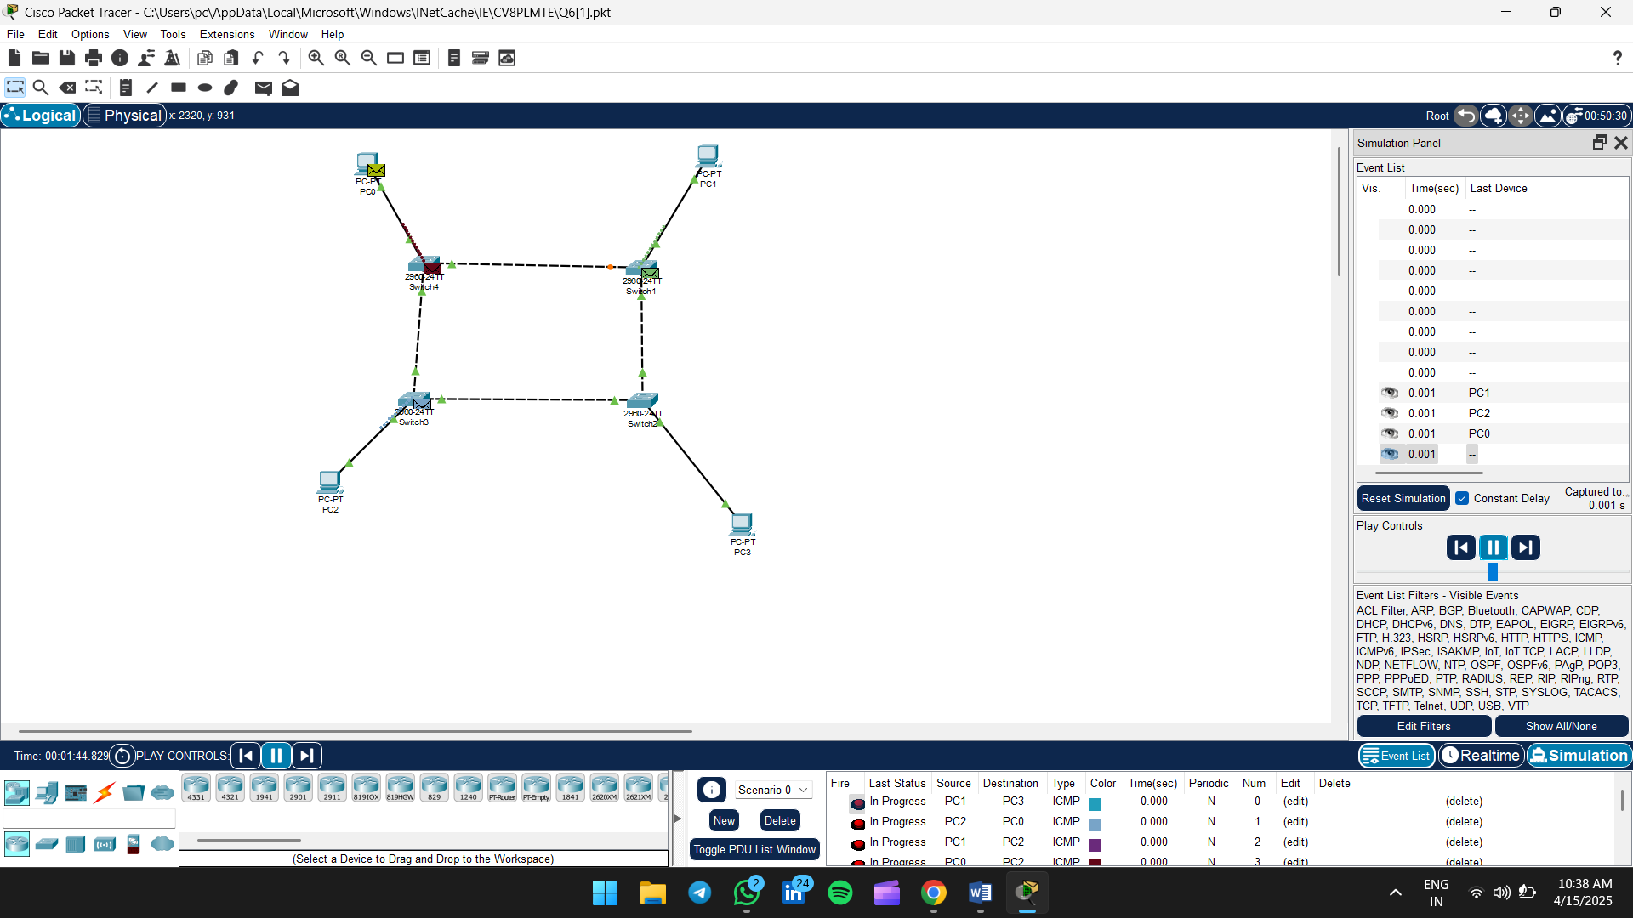

## ✅ Static Routing in Cisco Packet Tracer (3 Routers)

### 🖥 Step 1: Connect the Routers

Use **copper cross-over cables** to connect the routers like this:

Router1 ↔ Router2 ↔ Router3 ↔ Router1

(Connect via GigabitEthernet or FastEthernet ports)

### ⚙️ Step 2: Assign IP Addresses

Go to each router CLI and enter:

#### ****Router1****

enable

configure terminal

interface g0/0

ip address 12.0.0.1 255.255.255.0

no shutdown

exit

interface g0/1

ip address 13.0.0.1 255.255.255.0

no shutdown

exit

#### ****Router2****

enable

configure terminal

interface g0/0

ip address 12.0.0.2 255.255.255.0

no shutdown

exit

interface g0/1

ip address 23.0.0.2 255.255.255.0

no shutdown

exit

#### ****Router3****

enable

configure terminal

interface g0/0

ip address 13.0.0.3 255.255.255.0

no shutdown

exit

interface g0/1

ip address 23.0.0.3 255.255.255.0

no shutdown

exit

### 📍 Step 3: Add Static Routes

#### ****Router1****

ip route 23.0.0.0 255.255.255.0 12.0.0.2

#### ****Router2****

ip route 13.0.0.0 255.255.255.0 12.0.0.1

#### ****Router3****

ip route 12.0.0.0 255.255.255.0 13.0.0.1

### 🔄 Step 4: Test the Network

1. Click on **Simulation Mode**.
2. Use **Add Simple PDU (the lightning icon)**.
3. Click **Router1**, then **Router3** (and vice versa).
4. Check that the packets show **"Successful"** in the event list (as in your screenshot).